CASE STUDY 04:

Design Relational Storage Case Study
- Link: Design a relational storage solution

Requirements
Tailwind Traders is looking to move their existing public website database into Azure, as the website front end is being moved there as well. The website front end will initially only be deployed in 2 regions for redundancy. However, it is expected that as traffic increases the website will be replicated to other regions around the world. The database, which you are being asked to migrate, holds the product catalog, and all online orders. Currently the database runs on a single Microsoft SQL Server Always On availability group on premises.

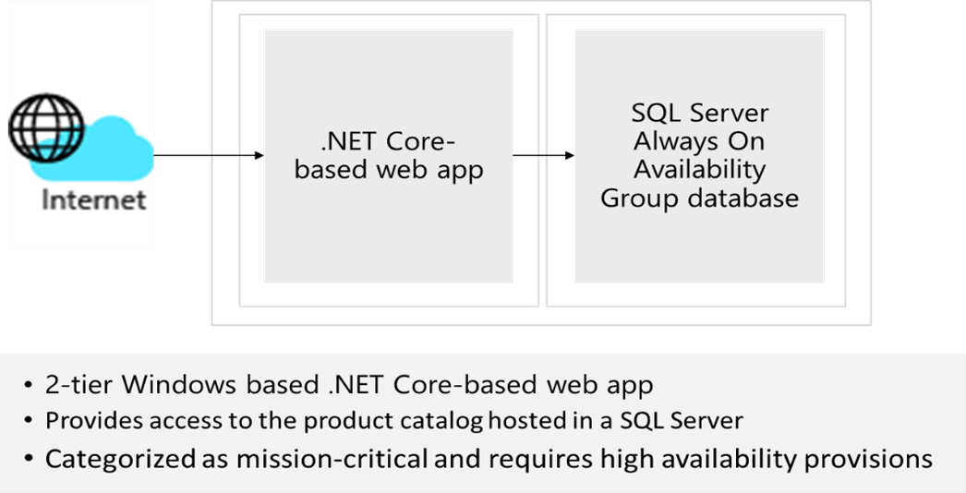
Primary concerns of Tailwind Traders:
- High availability. A primary concern for Tailwind Traders is that this database be highly available. The database is critical to their business. Any outages may result in lost sales or customer confidence.
- Website performance. While the performance of placing orders is normally satisfactory, browsing or searching pages with many items listed is reported as being “sluggish.”
- Security. Tailwind Traders is very concerned about personal or financial information stored in the database being exposed. In addition to implementing proper security measures, the security team needs to verify that industry standard best practices are implemented, when possible.

Tasks
1. Design the database solution. Your design should include authorization, authentication, pricing, performance, and high availability. Diagram what you decide and explain your solution.

Instructor Solution
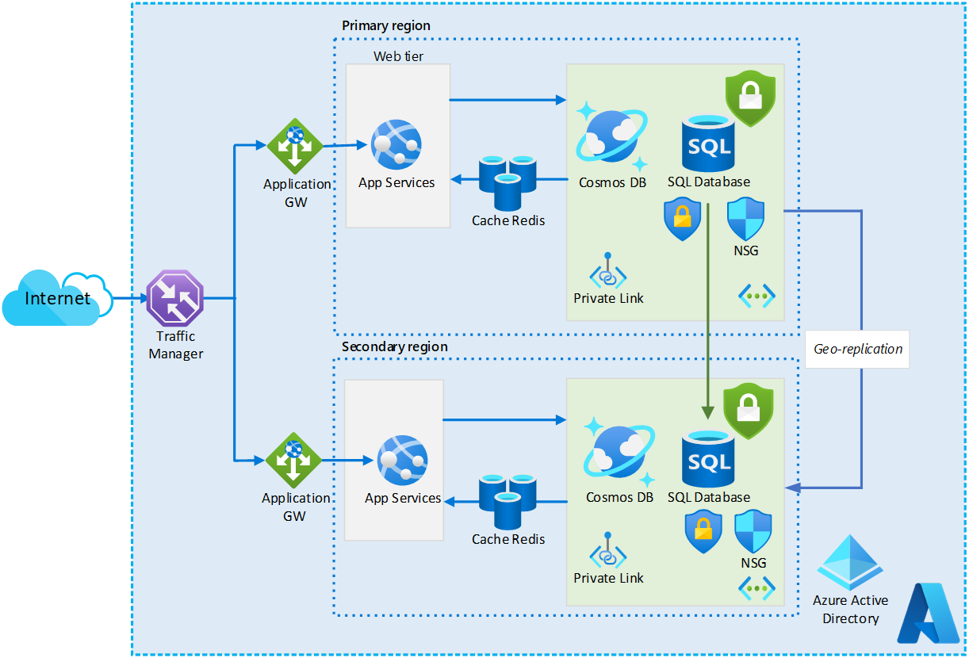

Design the database solution. Your design should include authorization, authentication, pricing, and high availability.
- Authorization. You can control authorization by using the Azure SQL Database and server level firewall functionality, allowing access only from the Tailwind Traders customer facing web servers. Private Endpoints may also be used to reduce the
attack surface of the Azure SQL Database, and NSGs may be implemented to implement an added layer of security. To remediate potential threats and get reports against industry standard best practices, consider enabling Azure Defender for SQL. To protect data, consider implementing Transparent Data Encryption (TDE), Dynamic Data Masking, and Always Encrypted.
- Authentication. From the authentication standpoint, once you integrate Tailwind Traders’ Active Directory environment with Azure Active Directory, your internal users will be able to authenticate to Azure SQL Database by using their Active Directory credentials. To provide access to an Azure SQL database from other Azure resources, such as Azure web apps, you can associate them with a managed identity.
- Pricing. We would recommend Azure SQL Database because there was no requirement that the customer remain in control of the database engine or host OS. If compatibility issues are found during the testing or pilot phase, Azure SQL Managed Instance or SQL Server on a VM may be needed.
- Performance. Simply moving to Azure and allocating sufficient resources to the Azure SQL Database MAY resolve the noted performance issues. However, you may want to consider sharding the data and moving the product catalog to a NoSQL
CosmosDB. This may provide a faster response time due to the materialized view CosmosDB would present. In addition, the database could be easily globally distributed. Note, this could require substantial effort to perform but may result in a better long-term solution.
- High Availability. We recommend business critical based on the high availability goals in the description. Specifically, it satisfies the immediate needs of not only storing relational data, but also providing low-latency, high-throughput transactions as well as the high availability of Always On and support for multiple read-only replicas. By deploying read-only replicas across different Azure regions, you could also minimize the latency of read operations from customers residing in these other regions, depending on the design of the website front end.

Instructor references
Materialized View pattern - Cloud Design Patterns | Microsoft Docs
General purpose and business critical service tiers - Azure SQL Database & SQL Managed Instance | Microsoft Docs

